**Traffic Light System**

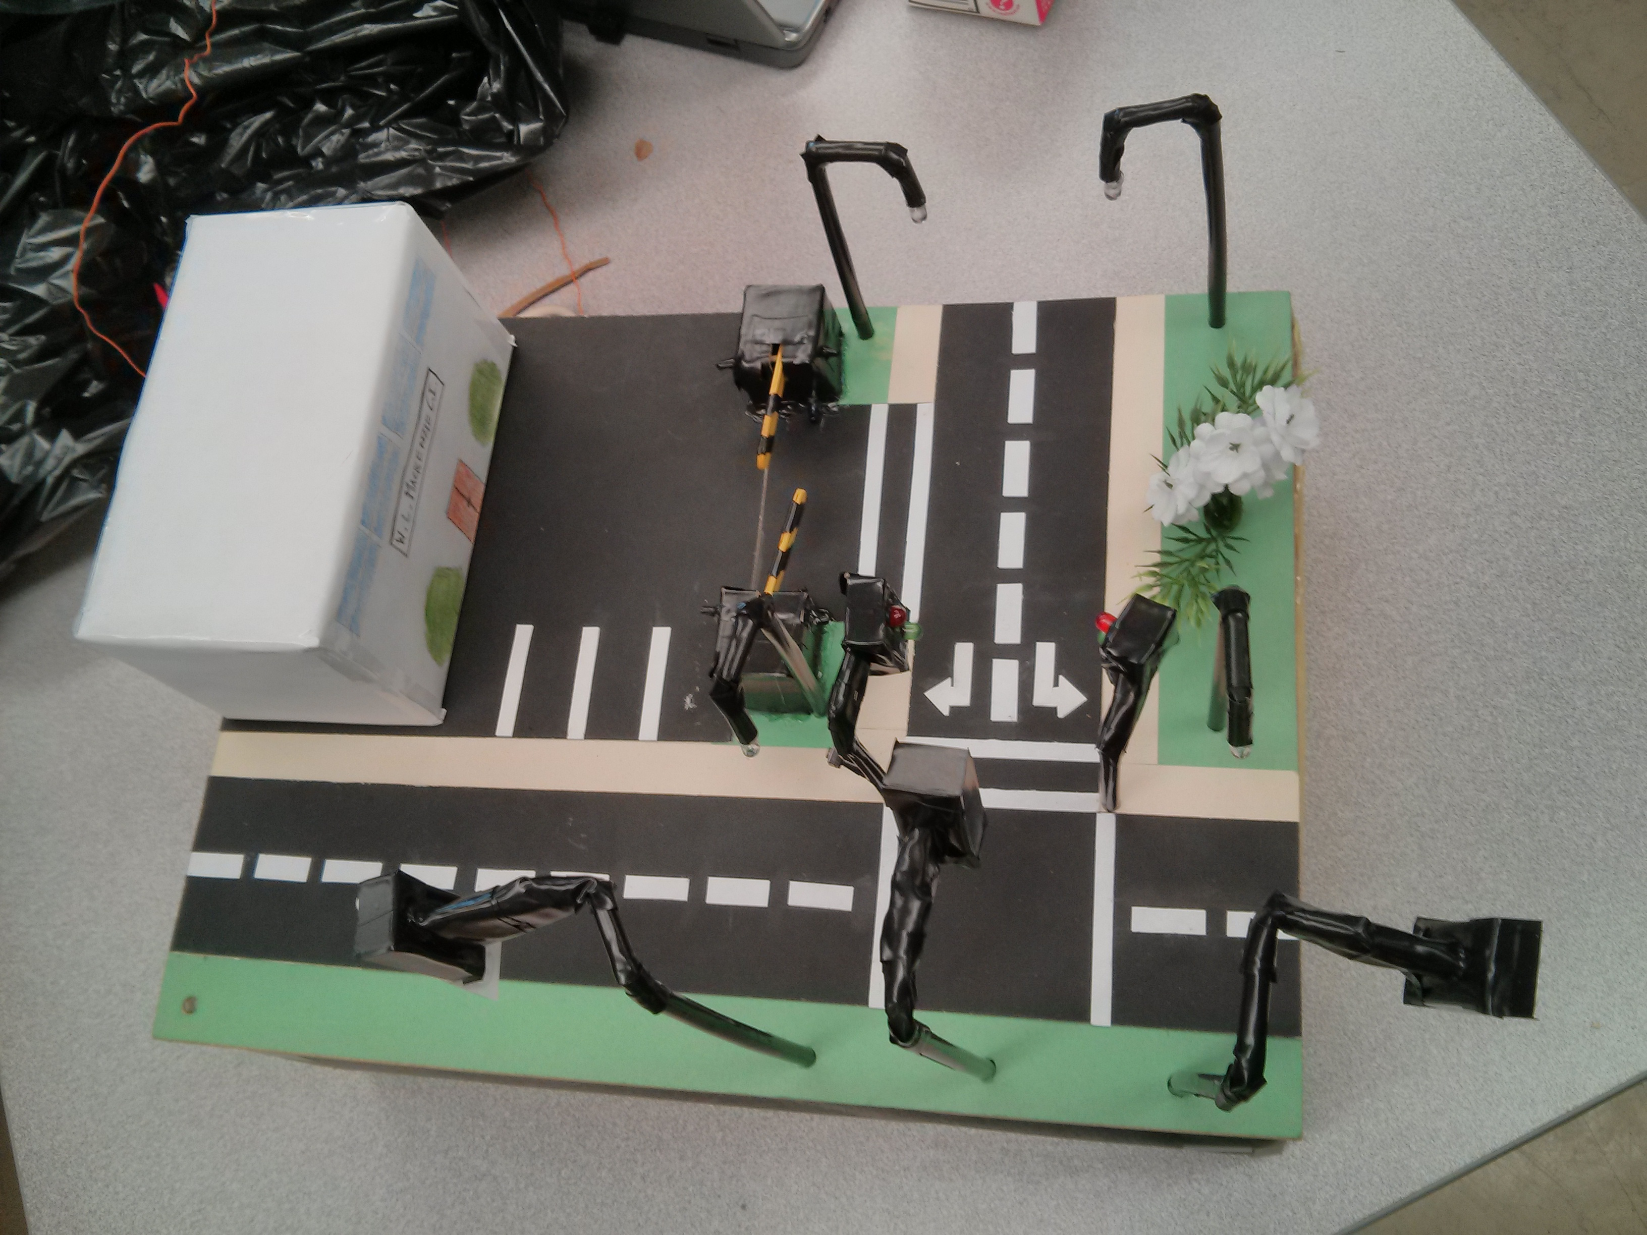

**Richard Dang, Erik Trinh & David Tsenter**

**TEJ 3M3**

**Mr. Wong**

**Thursday, January 16th, 2014**

**Planning**

**Introduction**

The goal of this project was to combine the knowledge taught to us throughout the course with its application to the real world. While the task of creating a T-intersection seems like a rather straightforward, it covers many essential areas of engineering such as coding a program to run individual components simultaneously and wiring all the circuits. The required components that had to be implemented includes a servo motor acting as a gate (controlled with IR sensors), a traffic light system with pedestrian cross lights (a button changes timing of traffic lights), and streetlights that turn on and off using an LDR depending on how bright the surrounding environment is. Not only was the project an excellent intro to the basics of engineering, it also gave us a chance to work as a team to accomplish a task that would have otherwise been quite difficult.

**Explanation**

Since the main purpose of the project was to create a T-intersection, we decided that in order to cover every requirement while keeping it simple, would be to have a one-way road intersect a two-way road. Our reasoning behind this consists of the fact that we could apply all three traffic lights while reducing the amount of work required (ex. less floor markings directing traffic). Another idea our group thought would cut down on work while maintaining all the necessities was to only include a single pedestrian light crossing. The reason was because a sidewalk adjacent to the traffic lights is not required. As for the placement of the streetlights, we placed four of them alongside the one-way road in order to light up the entrance to the parking lot. Finally, we managed to create two identical gates that are both controlled by a servo motor and IR sensors so that they open when there is incoming traffic.

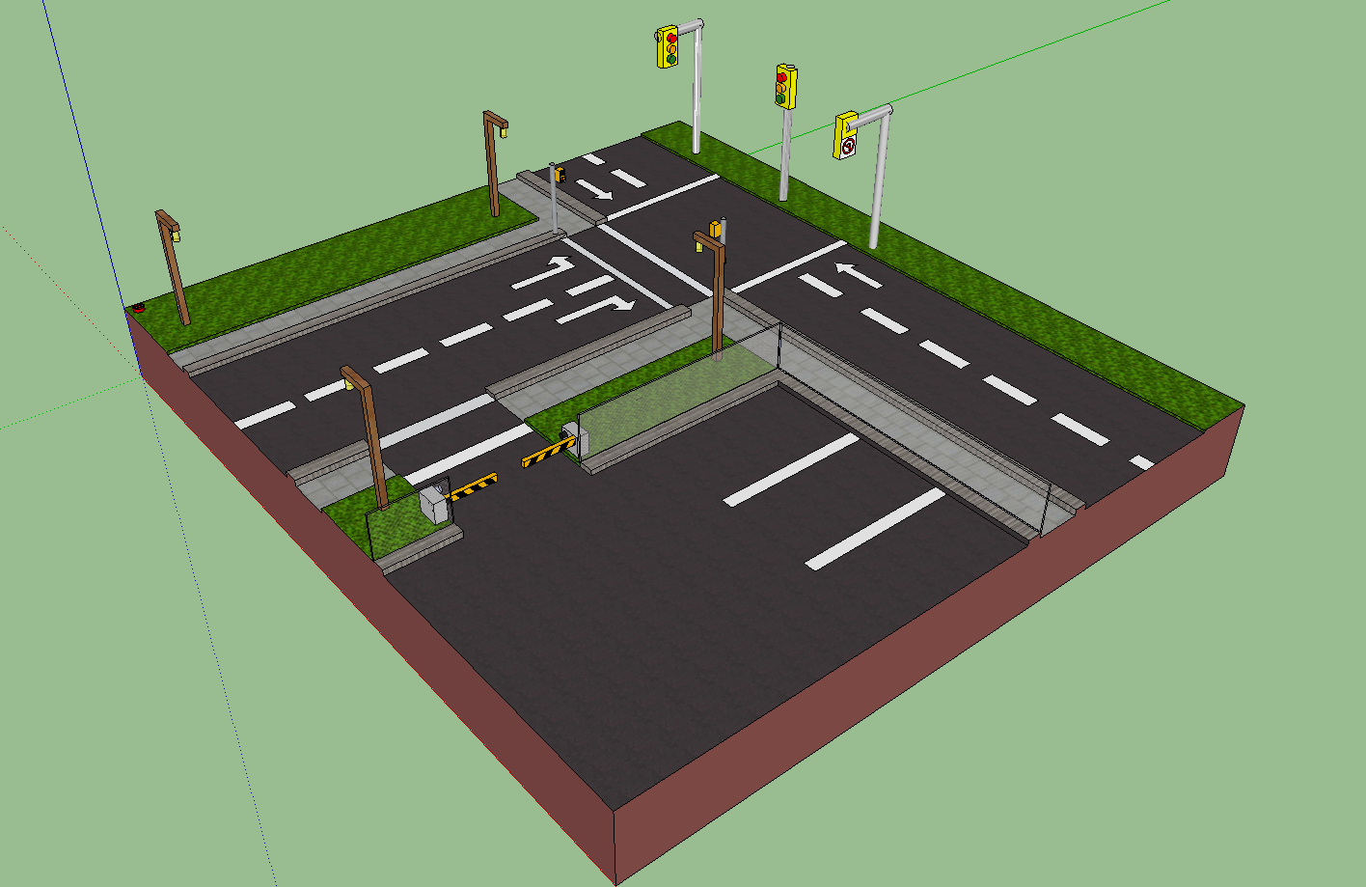

**3D View of Interestion**

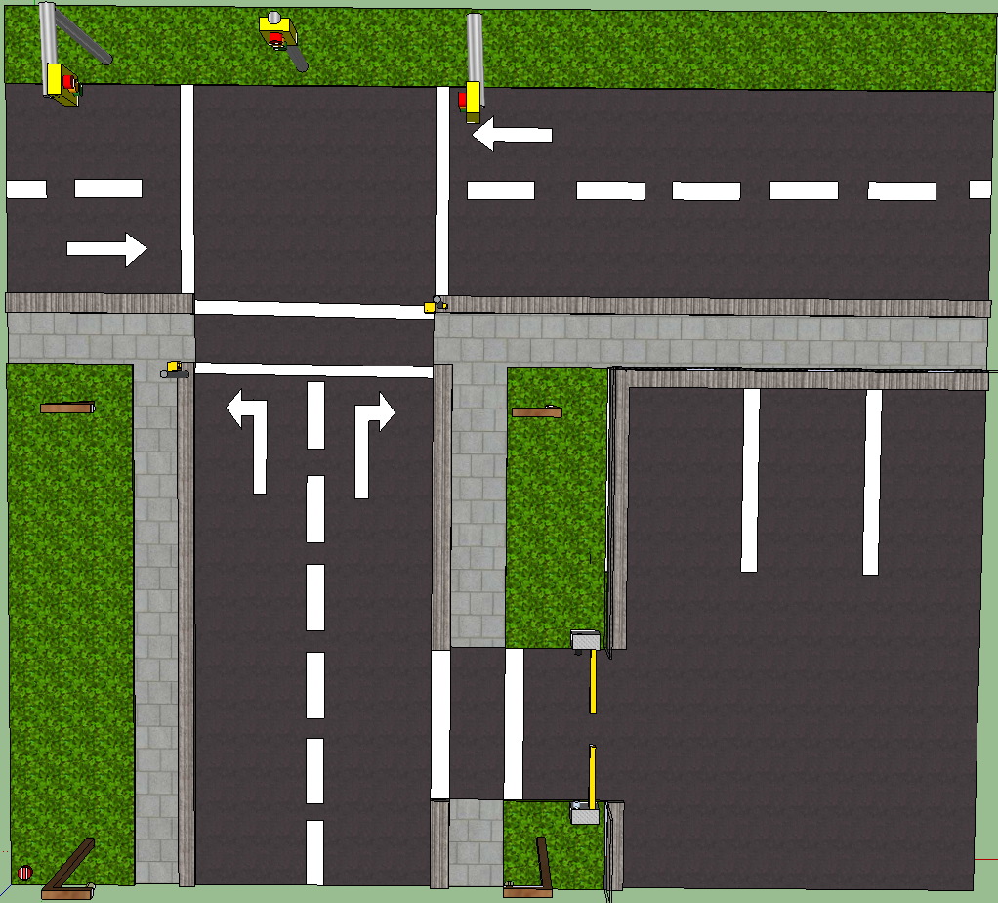

**Bird’s Eye View of Intersection**

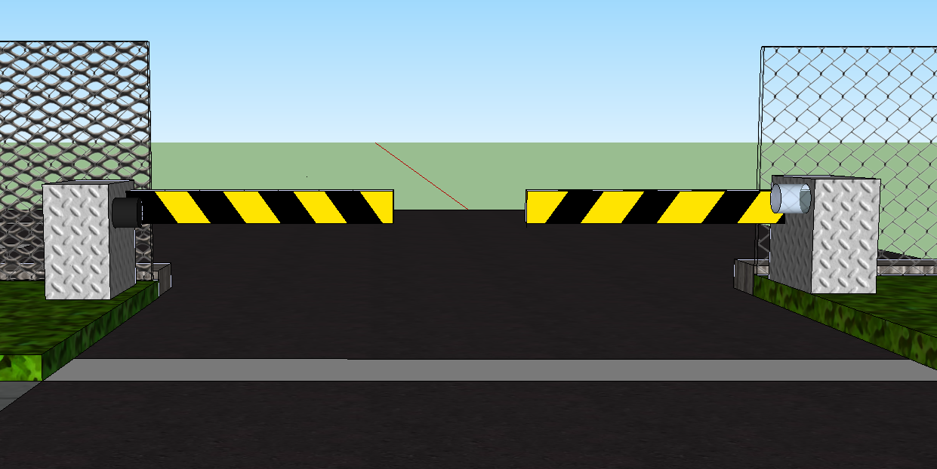

**Parking Lot Gates with IR Sensors**

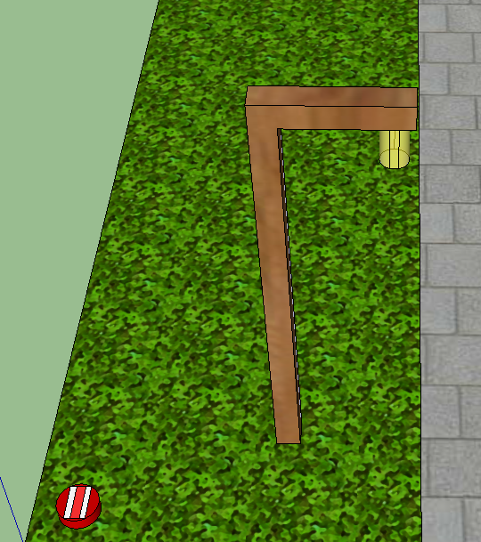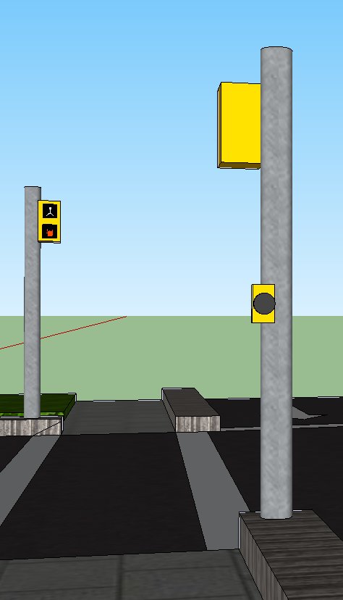

**Pedestrian Lights with Button Streetlight with LDR**

**Challenge**

The challenge we were assigned was to create a traffic light system through the implementation of Arduino to code and program several components working in unison. The first step of any project is to learn the basics which in this case was to be able to learn C programming language syntax and how simple circuits can be combined to form more complex ones. Afterwards the task at hand was to incorporate multiple components such as motors, buttons and LEDs into a single circuit so that they function as a whole.

Because this project resembles closely to a topic we encounter every day, it allows us insight into how a seemingly simple design can require a lot of logic, such as the process and interaction between traffic lights and pedestrian lights. Some of the greatest challenges that we encountered were coding the traffic light system and creating the two gates while controlling them with a single motor. Otherwise, the completion of the remaining components was manageable in the timeframe given to complete the project.

**Investigation**

Before rushing directly into constructing the final project, a lot of work had to go into the planning of how everything should be set up. By working with *Google Sketchup*, a 3D modelling program, we were able to plan out where each component would be placed around the intersection. After multiple revisions of the 3D model, we were ready to begin working with the Arduino board in order control basic functions of each component separately. For example, making a simple LED blink on and off as well as programming a fade effect.

Later, we went onto trying to figure out the logic behind the traffic light and pedestrian light stages. Once we had completed programing and wiring each component separately, the next step was to integrate each individual circuit into a single circuit, working simultaneously. Up until this point, all the heavy work was done and the final part of the project was to create the structure of the intersection and house all the circuits. In terms of design features, most of them are described in the planning-explanation section of this report.

As for the materials used, our group decided that we would use a wooden platform to outline our intersection and a shoebox to contain all the wires, along with the servo motor and Arduino board. Holes were drilled into the wood in order to surface the wires and an opening was made on the side of the shoebox to allow for an internal view. All traffic lights, pedestrian lights and streetlights were made using straws for the poles and Lego pieces or cardboard to create the housing of the LEDs. Lastly, the gates were created using popsicle sticks and string to lift the gates up and down, which is all concealed in a cardboard boxes.

Additionally, some changes had to be made throughout the project since not everything went according to plan. Many of the changes were minor such as changing the facing direction of the traffic lights, since they were bigger than expected and ended up blocking one another when put together.

**Evaluation**

Once the project was finally complete, we were really relieved since we did not think we were going to finish on time. Although some parts of the project were rushed in order to finish by the deadline, our group as a whole was really impressed by the final product. In the beginning our expectations were not very high but by the end we doubting our capabilities to work as a team. It was a very interactive project since each of us got to provide input on each section of the programming and circuitry. We believe that we made a very efficient and cooperative team, even though we did not always agree on the same things.

An area that could have been improved was in the aesthetics department, but we decided not to focus too much on physical appearance because time was scarce. The only difference between our plan and final project were small positioning changes. This includes the LDR location since it was placed too close to a streetlight which would have affected its operation.

If we were given this same project a second time around with the same timeline, we would manage our time more wisely considering we have a difficultly completing the necessary requirements on time. We also found that we could have further simplified the circuit and if given more time, also enhance the attractiveness of the final project. In conclusion, we really enjoyed working together on this traffic light system and hope that all the requirements were fulfilled to the fullest of our abilities.